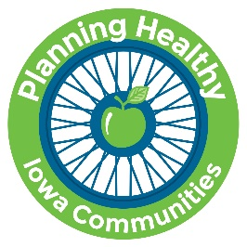
Planning Healthy Iowa Communities
2018 Essay Contest

Essay Topic:
"Connecting Public Health with Community Planning"

Eligibility:
This contest is open to current members of the Iowa Public Health Association and the Iowa Environmental Health Association.

Award:
The winner will be awarded a $500 stipend to attend the American Planning Association Iowa Chapter Planning Conference to be held October 17-19, 2018 at the Mid-America Center in Council Bluffs, Iowa.

Guidelines:
Essays should be between 500 and 750 words in length. They must be type-written, double-spaced, in English, and the pages must be numbered. Word length does not include cover page, bibliography, or footnotes. Every essay must include a Works Cited, Reference Page, or Bibliography (if applicable). It is to your advantage to have someone review your essay before you submit it to make sure it is complete, free from typographical and grammatical errors, and addresses the topic.

Submission Requirements:
Applicants are required to submit a cover page that includes his or her contact information and information about his or her organization and role in that organization.

Planning Healthy Iowa Communities encourages applicants to submit their cover page and essay as a single PDF document attached to an email. Please email your submissions to John Peterson at ankpetej@gmail.com with the words "APA Iowa 2018 Essay Contest" in the subject line. Please title the document with your first and last name.

The cover page and essay are due by end of day September 24, 2018. The winner will be notified by email no later than October 1, 2018.

